**Chapter 1**

**INTRODUCTION**

The high-visibility images reﬂect clear details of target scenes, which are critical to many vision- based techniques, such as object detection [1] and tracking [2]. But, images captured in low-light conditions are often of low visibility. The visual quality of images captured under low- light conditions, for one thing, is barely satisfactory. For another thing, it very likely hurts the performance of algorithms that are primarily designed for high-visibility inputs. Figure 1.1 provides several such examples, from which, we can see that many details, such as the paintings on the wall in the ﬁrst case, the distant ﬁeld on the bottom-left corner in the third case and the reﬂection on the ﬂoor in the last one, have almost been “buried” in the dark.

To make the buried information visible, low-light image enhancement is deﬁnitely demanded. Directly amplifying the low-light image is probably the most intuitive and simplest way to recall the visibility of dark regions. But, this operation gives birth to another problem, say relatively bright regions might be saturated and thus loss corresponding details. Histogram equalization (HE) [3] [4] [5], strategies can avoid the above problem by somehow forcing the output image to fall in the range [0,1]. Further, variational methods aim to improve the HE performance by imposing different regularization terms on the histogram. For instance, contextual and variational contrast enhancement (CVC) [6] tries to ﬁnd a histogram mapping that pays attention on large gray-level differences, while the work achieves improvement by seeking a layered difference representation of 2D histograms (LDR).

However, in nature, they focus on contrast enhancement instead of exploiting real illumination causes, having the risk of over- and under-enhancement. Another solution is Gamma correction that is a nonlinear operation on images. The main drawback is that the nonlinear operation of Gamma correction is carried out on each pixel individually without considering the relationship of a certain pixel with its neighbors, and thus may make enhanced results vulnerable and visually inconsistent with real scenes. In Retinex [7] theory, the dominant assumption is that the (color) image can be decomposed into two factors, say reﬂectance and illumination. Early attempts based on Retinex, such as single-scale Retinex (SSR) and multi-scale Retinex (MSR), treat the reﬂectance as the ﬁnal enhanced result, which often looks unnatural and frequently appears to be over- enhanced.

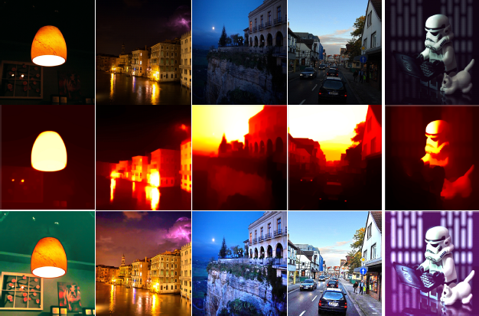

Fig. 1.1: Top Row: Natural low-light images. Middle Row: The illumination maps estimated by our method. Bottom Row: The results enhanced by our method.

* 1. **Overview**

The method proposed in tries to enhance contrast while preserving naturalness of illumination. Although it prevents results from over-enhancement, in our experiments, it performs less impressive than our method in terms of both efﬁciency and visual quality. Fu et al. proposed a method to adjust the illumination by fusing multiple derivations of the initially estimated illumination map (MF) [8]. The performance of MF is mostly promising. But, due to the blindness of illumination structure, MF may lose the realism of regions with rich textures. The most recent work of proposed a weighted variational model for simultaneous reﬂectance and illumination estimation (SRIE) [9].

The estimated reﬂectance and illumination, the target image can be enhanced by manipulating the illumination. As noticed in, inverted low- light images look like haze images, as shown in Fig. 1.2. Based on this observation, the authors of alternatively resorted to dehaze the inverted low-light images. After dehazing, the obtained unrealistic images are inverted again as the ﬁnal enhanced results. Recently, Li et al. followed this technical line and further improved the visual quality by ﬁrst over- segmenting the input image and then adaptively denoising different segments. Even though the above dehazing-like methods can provide reasonable results, the basic model they rely on is lacking in physical explanation. By contrast, our method has clear physical intuition.

Contribution Our method belongs to the Retinex-based category, which intends to enhance a low-light image by estimating its illumination map. It is worth noting that, different from the traditional Retinex-based methods like [7] that decompose an image into the reflectance and the illumination components, our method only estimates one factor, say the illumination, which shrinks the solution space and reduces the computational cost to reach the desired result. The illumination map is first constructed by finding the maximum intensity of each pixel in R, G and B channels. Then, we exploit the structure of the illumination to refine the illumination map. An Augmented Lagrangian Multiplier (ALM) based algorithm is given to exactly solve the refinement problem, while another sped-up solver is designed to intensively reduce the computational load. Experiments on several challenging images are conducted to reveal the advantages of our method in comparison with other state-of-the-art methods.

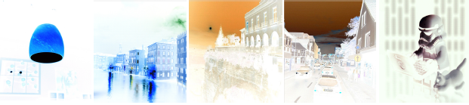

Fig. 1.2: The inverted versions (unrealistic images) of images shown in the top row of Fig. 1.1.

* 1. **Global Illumination**

Global illumination [10]orindirect illumination, is a general name for a group of algorithms used in 3D computer graphics that are meant to add more realistic lighting to 3D scenes. Such algorithms consider not only the light that comes directly from a light source (*direct illumination*), but also subsequent cases in which light rays from the same source are reflected by other surfaces in the scene, whether reflective or not (*indirect illumination*).

Theoretically, reflections, refractions, and shadows are all examples of global illumination, because when simulating them, one object affects the rendering of another (as opposed to an object being affected only by a direct light). In practice, however, only the simulation of diffuse inter-reflection or caustics is called global illumination.

Images rendered using global illumination algorithms often appear more photorealistic than those using only direct illumination algorithms. However, such images are computationally more expensive and consequently much slower to generate. One common approach is to compute the global illumination of a scene and store that information with the geometry (e.g., radiosity). The stored data can then be used to generate images from different viewpoints for generating walkthroughs of a scene without having to go through expensive lighting calculations repeatedly.

Radiosity ray tracing, beam tracing, cone tracing, path tracing, Metropolis light transport, ambient occlusion, photon mapping, and image based lighting are all examples of algorithms used in global illumination, some of which may be used together to yield results that are not fast, but accurate. These algorithms model diffuse inter-reflection which is a very important part of global illumination; however most of these (excluding radiosity) also model specular reflection, which makes them more accurate algorithms to solve the lighting equation and provide a more realistically illuminated scene. The algorithms used to calculate the distribution of light energy between surfaces of a scene are closely related to heat transfer simulations performed using finite-element methods in engineering design.

In real-time 3D graphics, the diffuse inter-reflection component of global illumination is sometimes approximated by an "ambient" term in the lighting equation, which is also called "ambient lighting" or "ambient color" in 3D software packages. Though this method of approximation (also known as a "cheat" because it's not really a global illumination method) is easy to perform computationally, when used alone it does not provide an adequately realistic effect. Ambient lighting is known to "flatten" shadows in 3D scenes, making the overall visual effect more bland. However, used properly, ambient lighting can be an efficient way to make up for a lack of processing power.

**1.3 History of Low Light Images**

In the early 1900s, a few notable photographers, Alfred Stieglitz and William Fraser, began working at night. The first known female night photographer is Jessie TarboxBeals. The first photographers known to have produced large bodies of work at night were Brassai and Bill Brandt.

In 1932, Brassai published *Paris de Nuit*, a book of black-and-white photographs of the streets of Paris at night. During World War II, British photographer Brandt took advantage of the black-out conditions to photograph the streets of London by moonlight.

Photography at night found several new practitioners in the 1970s, beginning with the black and white photographs that Richard Misrach made of desert flora (1975–77). Joel Meyerowitz made luminous large format color studies of Cape Cod at nightfall which were published in his influential book, Cape Light (1979). Jan Staller’s twilight color photographs (1977–84) of abandoned and derelict parts of New York City captured uncanny visions of the urban landscape lit by the glare of sodium vapor street lights.

By the 1990s, British-born photographer Michael Kenna had established himself as the most commercially successful night photographer. His black-and-white landscapes were most often set between dusk and dawn in locations that included San Francisco, Japan, France, and England. Some of his most memorable projects depict the Ford Motor Company's Rouge River plant, the Ratcliffe-on-Soar Power Station in the East Midlands in England, and many of the Nazi concentration camps scattered across Germany, France, Belgium, Poland and Austria.

During the beginning of the 21st century, the popularity of digital cameras made it much easier for beginning photographers to understand the complexities of photographing at night. Today, there are hundreds of websites dedicated to night photography.

**Chapter 2**

**LITERATURE SURVEY**

This chapter discusses about Low Light Image Enhancement via Illumination Map Estimation, and Existing algorithms and also discusses about the various existing simulator in the grid.

**1) Digital Image Processing for Image Enhancement and Information Extraction**

Digital image processing [11] plays a vital role in the analysis and interpretation of Remotely sensed data. Especially data obtained from Satellite Remote Sensing, which is in the digital form, can best be utilized with the help of digital image processing. Image enhancement and information extraction are two important components of digital image processing. Image enhancement techniques help in improving the visibility of any portion or feature of the image suppressing the information in other portions or features. Information extraction techniques help in obtaining the statistical information about any particular feature or portion of the image. These techniques are discussed in detail and illustrated in this article.

**2) A low-light image enhancement method for both denoising and contrast enlarging**

A novel united low-light image enhancement [12] framework for both contrast enhancement and denoising is proposed. First, the low-light image is segmented into super pixels, and the ratio between the local standard deviation and the local gradients is utilized to estimate the noise-texture level of each super pixel. Then the image is inverted to be processed in the following steps. Based on the noise-texture level, a smooth base layer is adaptively extracted by the BM3D filter, and another detail layer is extracted by the first order differential of the inverted image and smoothed with the structural filter. These two layers are adaptively combined to get a noise-free and detail-preserved image. At last, an adaptive enhancement parameter is adopt into the dark channel prior dehazing process to enlarge contrast and prevent over/under enhancement. Experimental results demonstrate that our proposed method outperforms traditional methods in both subjective and objective assessments.

**3) Low-Light Image Enhancement Using Adaptive Digital Pixel Binning**

Image enhancement algorithm for low-light scenes [13] in an environment with insufficient illumination. Simple amplification of intensity exhibits various undesired artifacts: noise amplification, intensity saturation, and loss of resolution. In order to enhance low-light images without undesired artifacts, a novel digital binning algorithm is proposed that considers brightness, context, noise level, and anti-saturation of a local region in the image. The proposed algorithm does not require any modification of the image sensor or additional frame-memory; it needs only two line-memories in the image signal processor (ISP). Since the proposed algorithm does not use an iterative computation, it can be easily embedded in an existing digital camera ISP pipeline containing a high-resolution image sensor

**Chapter 3**

**PROBLEM STATEMENT**

Several systems have been proposed to design and enhance the images which are taken in low light conditions, the visual quality of images captured under lowlight conditions, for one thing, is barely satisfactory. For another thing, it very likely hurts the performance of algorithms that are primarily designed for high-visibility inputs.

**3.1 Existing system**

* **Histogram equalization(HE)**method usually increases the global contrast of many images, especially when close contrast values represent the usable data of the image. Histogram equalization accomplishes this by effectively spreading out the most frequent intensity values. The method is useful in images with backgrounds and foregrounds that are both bright or both dark. Histogram equalization often produces unrealistic effects in photographs; however, it is very useful for scientific images like thermal, satellite or x-ray images, often the same class of images to which one would apply false-color.
* **Contextual and variational contrast enhancement(CVC) [6]**This paper proposes an algorithm which enhances the contrast of an input image using inter-pixel contextual information. The algorithm uses a two-dimensional (2D) histogram of the input image constructed using mutual relationship between each pixel and its neighboring pixels. A smooth 2D target histogram is obtained by minimizing the sum of Frobenius norms of the differences from the input histogram, and the uniformly distributed histogram. The enhancement is achieved by mapping the diagonal elements of the input histogram to the diagonal elements of the target histogram. Experimental results show that the algorithm produces better or comparable enhanced images than four state-of-the-art algorithms.
* **Simultaneous reflectance and illumination estimation (SRIE) [9]** a weighted variational model to estimate both the reflectance and the illumination from an observed image. We show that, though it is widely adopted for ease of modeling, the log-transformed image for this task is not ideal. Based on the previous investigation of the logarithmic transformation, a new weighted variational model is proposed for better prior representation, which is imposed in the regularization terms. Different from conventional variational models, the proposed model can preserve the estimated reflectance with more details. Moreover, the proposed model can suppress noise to some extent. An alternating minimization scheme is adopted to solve the proposed model. Experimental results demonstrate the effectiveness of the proposed model with its algorithm. Compared with other variational methods, the proposed method yields comparable or better results on both subjective and objective assessments.
* **Gamma Correction (GC)**Gamma correction, or often simply gamma, is the name of a nonlinear operation used to encode and decode luminance or tristimulus values in video or still image systems. Gamma encoding of images is used to optimize the usage of bits when encoding an image, or bandwidth used to transport an image, by taking advantage of the non-linear manner in which humans perceive light and color. The human perception of brightness, under common illumination conditions (not pitch black nor blindingly bright), follows an approximate power function with greater sensitivity to relative differences between darker tones than between lighter ones, consistent with the Stevens' power law for brightness perception. If images are not gamma-encoded, they allocate too many bits or too much bandwidth to highlights that humans cannot differentiate, and too few bits or too little bandwidth to shadow values that humans are sensitive to and would require more bits/bandwidth to maintain the same visual quality.
* **Multi-deviation fusion method (MF)** a straightforward and efficient fusion-based method for enhancing weakly illumination images that uses several mature image processing techniques. First, employ an illumination estimating algorithm based on morphological closing to decompose an observed image into a reflectance image and an illumination image.
* **Layered Difference Representation (LDR)** A novel contrast enhancement algorithm based on the layered difference representation of 2D histograms is proposed in this paper. We attempt to enhance image contrast by amplifying the gray-level differences between adjacent pixels. To this end, obtain the 2D histogram h(k, k+l) from an input image, which counts the pairs of adjacent pixels with gray-levels k and k+l, and represent the gray-level differences in a tree-like layered structure. Then, we formulate a constrained optimization problem based on the observation that the gray-level differences, occurring more frequently in the input image, should be more emphasized in the output image. We first solve the optimization problem to derive the transformation function at each layer. We then combine the transformation functions at all layers into the unified transformation function, which is used to map input gray-levels to output gray-levels. Experimental results demonstrate that the proposed algorithm enhances images efficiently in terms of both objective quality and subjective quality.
* **Dehazing based method (DeHz)** a method for dehazing images. A dark envelope image is derived with the bilateral minimum filter and a bright envelope is derived with the bilateral maximum filter. The ambient light and transmission of the scene are estimated from these two envelope images. An image without haze is reconstructed from the estimated ambient light and transmission.
* **Natural Preserved Enhancement algorithm (NPE)** Outdoor images captured in bad-weather conditions usually have poor intensity contrast and color saturation since the light arriving at the camera is severely scattered or attenuated. The task of improving image quality in poor conditions remains a challenge. Existing methods of image quality improvement are usually effective for a small group of images but often fail to produce satisfactory results for a broader variety of images. In this paper, we propose an image enhancement method, which makes it applicable to enhance outdoor images by using content-adaptive contrast improvement as well as contrast-dependent saturation adjustment.

**3.1.1Drawbacks of Existing systems**

* The operation of HE, AHE and GC cannot be directly manipulating on each channel of R, G and B leads to visually inconsistent with real scenes, considerable tone of images
* AHE, CVC and LDR cannot effectively recall the images in the dark regions, this problem almost exists always
* NPE, SRIE and CVC is not efficient in time and cost
* The lightness is somewhat dime for CVC, LDR, AHE, NPE and MF, which can be further enhanced by gamma correction

**3.2Proposed System**

The proposed system simple yet effective low-light image enhancement (LIME) method. More concretely, the illumination of each pixel is first estimated individually by finding the maximum value in R, G and B channels. Further, we refine the initial illumination map by imposing a structure prior on it, as the final illumination map.

Our proposed system belongs to the Retinex-based category, which intends to enhance a low-light image by estimating its illumination map. It is worth noting that, different from the traditionalRetinex-based methods like thatdecompose an image into the reflectance and the illuminationcomponents, our method only estimates one factor, say the illumination, which shrinks the solution space and reduces thecomputational cost to reach the desired result. Welcome to the rice fields,the illumination map is first constructed by finding the maximum intensity of each pixel in R, G and B channels. Then, we exploit the structure of the illumination to refine the illumination map. An Augmented Lagrangian Multiplier (ALM) based algorithm is given to exactly solve the refinement problem, while another sped-up solver is designed to intensively reduce the computational load. Experiments on a number of challenging images are conducted to reveal the advantages of our method in comparison with other state-of-the-art methods.

Lightness order error (LOE) is objective matric to measure the performance of the systems. The lower the LOE is, the better the enhancement preserves the naturalness of lightness. Due to the heavy load of computing LOE, down sampling is used to reduce the complexity. The HDR reconstruction results from a set of bracketed exposures are more proper to act as the reference. The HDR dataset contains seven groups, several samples from this dataset are shown in Fig. 3.1. Table 1 contains the LOE numbers of all the competitors on the HDR dataset. From the numbers, we observe that our LIME significantly outperforms the others. In addition, we give the visual comparison on two cases in Fig. 3.2, from which, we can find that the results obtained by LIME are more visually pleasant and closer to the references than the others.

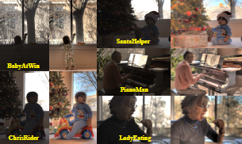

Fig 3.1: Samples from HDR data set

|  |  |  |  |  |  |
| --- | --- | --- | --- | --- | --- |
| **Method** | **Baby at win** | **Chris Rider** | **Santa helper** | **Piano man** | **Lady eating** |
| **HE** | 4.536 | 2.433 | 3.652 | 3.759 | 3.395 |
| **GC** | 4.518 | 2.430 | 3.645 | 3.755 | 3.401 |
| **LDR** | 4.501 | 2.509 | 3.670 | 3.775 | 3.401 |
| **MF** | 3.626 | 2.124 | 3.145 | 3.113 | 2.749 |
| **NPE** | 3.811 | 3.191 | 3.773 | 3.872 | 3.250 |
| **DeHz** | 4.591 | 2.854 | 3.732 | 3.837 | 3.408 |
| **SRIE** | 4.133 | 2.770 | 3.497 | 3.233 | 3.196 |
| **LIME** | **3.263** | **2.356** | **3.352** | **2.513** | **2.305** |

Table1: Quantitative performance comparison on the HDR dataset in terms of LOE.

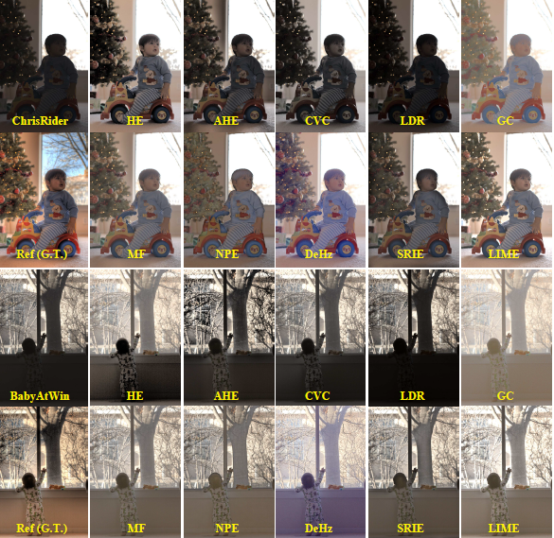

Fig. 3.2: Visual comparison among the competitors on the HDR dataset.

**3.2.1 Advantages of proposed system**

* LIME is the efficient and efficient method to enhance low light images.
* LIME operation will enhance the details of the image and also removes the nose present in the image.
* LIME is more visually pleasant and closer to the references than the other existing systems.
* Lightness order error (LOE) is lessor for the LIME than other existing systems.

**Chapter 4**

**METHODOLOGY**

This method is built upon the following (Retinex) model, which explains the formation of a low-light image:

L = R °T;

where L and R are the captured image and the desired recovery, respectively. Furthermore, T represents the illumination map, and the operator _ means element-wise multiplication. In this method, we assume that, for colour images, three channels share the same illumination map. With slight abuse of notations, we use T (^T) to represent one-channel and three channel illumination maps interchangeably. The model is with clear physical meaning, say the observed image can be decomposed into the product of the desired light-enhanced scene and the illumination map.

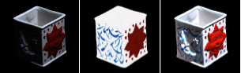

1. Input (b)reflectance (c)our desired

Fig. 4.1: Different purposes of intrinsic image decomposition and low-light image enhancement

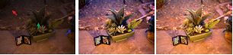

Low light input DeHz LIME

Fig 4.2: Comparison with the same illumination map

The model of our problem is similar with that of the intrinsic image decomposition which attempts to decompose the input into two components1. However, the goal of the intrinsic image decomposition is to recover the reflectance component and the shading one from the givenimage. As shown in Fig. 4.1 (b), the reflectance loses the shape of the box (the ground truth reflectance is from, which does not satisfy the purpose of low-light image enhancement. The expectation of our work is to recall the visual content of dark regions as well as keep the visual realism, as shown in Fig. 4.1 (c). Some researchers noticed the unrealism of using the reflectance as the enhanced result, for example, and tried to project the modified illumination back to the reflectance by ^R°f(^T), where ^R and ^T are the recovered reflectance and illumination respectively, and f(.) stands for a manipulation operator such as Gamma correction

. We can see that the desired result of enhancement is obtained by somehow combining the decomposed components again. Further, due to the ill-posedness of the decomposition problem, more priors are required to help constrain the space of solution. But if the task is just to lighten low-light images, which is this paper concentrates on, it is not necessary to decompose the input image into two components. Because, by slightly transforming (1), we have R = L=T, where the division is element-wise. It is apparent that the estimation of T is key to the recovery of R. In this way, the problem is simplified, only demanding the estimation of T.

**Algorithm:** LIME

**Input:** Low-light Input L, positive coefficient α, Gamma transformation parameter

1. Estimate initial illumination map ^T on L

2. Refine illumination map T based on ^T via exact

solver Alg. 1 or sped-up solver;

3. Gamma correction on T via T T;

4. Enhance L using T according to L = R _ T

5. If denoising and recomposing needed, then denoise

R by BM3D (Rd) and recompose

**Output:** Final enhanced result

**Chapter 5**

**RESULTS**

In this section, we first see the performance difference between different weighting strategies, and the effect of involved parameters. Next, the analysis of our exact and speedup solvers is given. Then, we qualitatively and quantitatively compare our LIME with several state-of-the-art methods, including Histogram Equalization (HE), Adaptive Histogram Equalization (AHE), Gamma Correction (GC), Contextualand Variational Contrast enhancement (CVC) [6], Layered Difference Representation (LDR) , dehazing based method (DeHz), Multi-deviation Fusion method (MF) [3], Naturalness Preserved Enhancement algorithm (NPE) [9] and Simultaneous Reflection and Illumination Estimation (SRIE). All the codes are in Matlab2, which ensures the fairness of time comparison. All the experiments are conducted on a PC running Windows 7 OS with 64G RAM and 2.4GHz CPU.

**5.1 Comparison**

Figures 5.1 and 5.2 provide several comparisons. The inputs are from the top row of Fig. 1. The operations of HE, AHE and GC are executed on the V channel of images by first converting it from the RGB colorspace to the HSV one and then converting the processed HSV back to the RGB colorspace. Directly manipulating on each channel of R, G and B leads results to be visually inconsistent with real scenes, e.g. considerably changing the tone of images, . We can observe from Fig. 5.1 and 5.2 that AHE, CVC and LDR can not effectively recall the information in dark regions. This problem almost exist always. HE, DeHz, MF, SRIE and NPE outperform AHE, CVC and LDR in most of the given examples, as shown in Fig. 5.1 and 52, but are inferior to our method in terms of visual quality. In terms of time cost, although our method spends more than HE, AHE, LDR and GC, it is comparable to or even more efficient than MF and DeHz, while much more efficient than NPE, SRIE and CVC. Most cost of DeHz comes from the estimation of atmospheric light.

From the pictures shown in Fig. 5.1 and 52, the lightness is still somewhat dim for CVC, LDR, AHE, NPE, MF and NPE, which can be further enhanced by gamma correction intuitively. We note that SRIE itself has a gamma correction step on the estimated illumination. Figure 5.3 depicts the results after executing gamma correction. For the pictures obtained by different methods, we tune the parameter to achieve their

possible best visual quality. The lightness is indeed increased, but similar to using only GC, the visual artifact appears for all the further enhanced results of AHE, CVC, LDR, MF, DeHz and NPE. This is mainly because the nonlinear operation of GC is carried out on each pixel individually without considering the relationship of a certain pixel with its neighbors. Although our LIME also employs the GC as described in Sec. II-E, the estimated illumination map itself is structure-aware and thus LIME survives from such artifacts. It is worth noticing that the parameter used in LIME is fixed to 0.8 for all the experiments in Sec. III instead of being fine-tuned image by image.

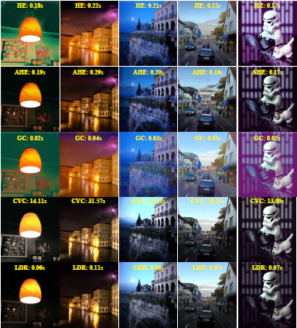

Fig 5.1: Result comparison between HE, AHE, GC, CVC and LDR. Please see also Fig. 5.2.

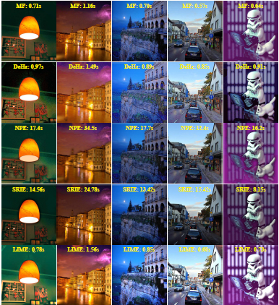

Fig. 5.2: Result comparison between MF, DeHz, NPE, SRIE and LIME. Please see also Fig. 5.1.

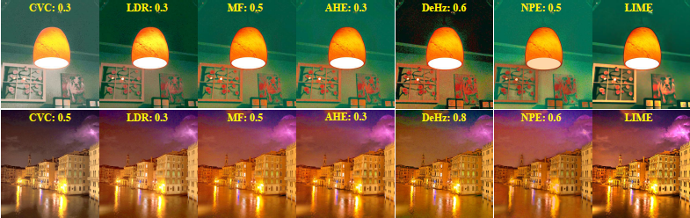

Fig. 5.3: Results with GC operation as post-processing. We tune (given on the top of each picture) of GC to achieve their best possible visual quality.

**CONCLUSION**

This paper is proposed an efficient and effective method to enhance low-light images. The key to the low-light enhancement is how well the illumination map is estimated. The structure-aware smoothing model has been developed to improve the illumination consistency. We have designed two algorithms: one can obtain the exact optimal solution to the target problem, while the other alternatively solves the approximate problem with significant saving of time. Moreover, our model is general to different (structure) weighting strategies. The experimental results have revealed the advance of our method compared with several state-of-the-art alternatives. It is positive that our low-light image enhancement technique can feed many vision-based applications, such as edge detection, feature matching, object recognition and tracking, with high visibility inputs, and thus improve their performance.

**REFERENCES**

[1] D. Oneata, J. Revaud, J. Verbeek, and C. Schmid, “Spatio-temporal object detection proposals,” in ECCV, pp. 737–752, 2014.

[2] K. Zhang, L. Zhang, and M. Yang, “Real-time compressive tracking,” in ECCV, pp. 866–879, 2014.

[3] E. Pisano, S. Zong, B. Hemminger, M. DeLuce, J. Maria, E. Johnston, K. Muller, P. Braeuning, and S. Pizer, “Contrast limited adaptive histogram equalization image processing to improve the detection of simulated spiculations in dense mammograms,” Journal of Digital Imaging, vol. 11, no. 4, pp. 193–200, 1998.

[4] H. Cheng and X. Shi, “A simple and effective histogram equalization approach to image enhancement,” Digital Signal Processing, vol. 14, no. 2, pp. 158–170, 2004.

[5] M. Abdullah-Al-Wadud, M. Kabir, M. Dewan, and O. Chae, “A dynamic histograme equalization for image contrast enhancement,” IEEE Trans. on Consumer Electronics, vol. 53, no. 2, pp. 593–600, 2007.

[6] T. Celik and T. Tjahjadi, “Contextual and variational contrast enhancement,” TIP, vol. 20, no. 12, pp. 3431–3441, 2011.

[7] E. Land, “The retinex theory of color vision,” Scientific American, vol. 237, no. 6, pp. 108–128, 1977.

[8] X. Fu, D. Zeng, Y. Huang, Y. Liao, X. Ding, and J. Paisley, “A fusion-based enhancing method for weakly illuminated images,” Signal

Processing, vol. 129, pp. 82–96, 2016.

[9] X. Fu, D. Zeng, Y. Huang, X. Zhang, and X. Ding, “A weighted variational model for simultaneous reflectance and illumination estimation,” in CVPR, pp. 2782–2790, 2016.

[10] <https://www.in.tu-clausthal.de/fileadmin/homes/CG/data_pub/paper/GISTAR.pdf>

[11] <http://civil.iisc.ernet.in/~nagesh/rs_docs/Imagef.pdf>

[12] <http://ieeexplore.ieee.org/document/7351501/>

[13] <https://www.ncbi.nlm.nih.gov/pubmed/26121609>

**Chapter 4**

**SYSTEM REQUIREMENT SPECIFICATION**

The system requirement specification is required for the software to develop, and we need few tools and the programming languages to code the software and a minimum hardware requirement for the tools and the programming language to run upon so here are the minimum hardware and the software requirements.

**4.1 Hardware Requirement**

* Processor : 1Ghz
* RAM : 2GB
* Hard disk : 40GB
  1. **Software Requirement**
* Cloud services : Live public cloud deployment
* Front end technologies : HTML, CSS, JavaScript
* Back end technologies : JDK 1.8, J2EE
* Servers : Apache Tomcat v9.0
* Database : MySQL
* Tools : Eclipse IDE

**Chapter 5**

**GANTT CHART**

|  |  |  |  |  |  |  |  |  |  |  |  |  |
| --- | --- | --- | --- | --- | --- | --- | --- | --- | --- | --- | --- | --- |
|  | February | | | | March | | | | April | | | |
| Title/Week | 1 | 2 | 3 | 4 | 1 | 2 | 3 | 4 | 1 | 2 | 3 | 4 |
| Planning |  | | | |  | | | |  | | | |
| Gathering requirements |  | | | |  | | | |  | | | |
| Designing |  | | | |  | | | |  | | | |
| Development |  | | | |  | | | |  | | | |
| Coding |  | | | |  | | | |  | | | |
| Implementation |  | | | |  | | | |  | | | |
| Testing |  | | | |  | | | |  | | | |
| Delivery |  | | | |  | | | |  | | | |

**REFERENCES**

**[1]**A. Burd et al., “Pi of the sky-all-sky, real-time search for fast optical transients,” New Astronomy, vol. 10, no. 5, pp. 409 – 416, 2005.

**[2]** O. Rubel, C. Geddes, M. Chen, E. Cormier-Michel, and E. Bethel, “Feature-based analysis of plasma-based particle acceleration data,” Visualization and Computer Graphics, IEEE Transactions on, vol. 20, no. 2, pp. 196–210, 2014.

**[3]** T. Tucker, M. Marra, and J. Friedman, “Massively parallel sequencing: The next big thing in genetic medicine,” The American Journal of Human Genetics, vol. 85, no. 2, pp. 142–154, 2009.

**[4]** The SAGE Handbook of Social Network Analysis, 0th ed. SAGE Publications Ltd, 2014.

**[5]** T. Hey, S. Tansley, and K. Tolle, Eds., The Fourth Paradigm: Data-Intensive Scientific Discovery. Microsoft Research, 2009.

**[6]** D. Talia, “Workflow systems for science: Concepts and tools,” ISRN Software Engineering, 2013.

**[7]** M. Bux and U. Leser, “Parallelization in scientific workflow management systems,” CoRR, 2013.

**[8]** J. Yu and R. Buyya, “A taxonomy of scientific workflow systems for grid computing,” SIGMOD Rec., vol. 34, no. 3, pp. 44–49, 2005.

**[9]** J. Goecks, A. Nekrutenko, J. Taylor, and T. G. Team, “Galaxy: a comprehensive approach for supporting accessible, reproducible, and transparent computational research in the life sciences,” Genome Biology, vol. 11, no. 8, p. R86, 2010.

**[10]** K. Wolstencroft et al., “The Taverna workflow suite: designing and executing workflows of Web Services on the desktop, web or in the cloud,” Nucleic Acids Research, vol. 41, pp. 557–561, 2013.

**[11]** V. Podpeˇcan, M. Zemenova, and N. Lavraˇc, “Orange4ws environment for service-oriented data mining,” Comput. J., vol. 55, no. 1, pp. 82–98, 2012.

**[12]** B. Ludscher, I. Altintas, C. Berkley, D. Higgins, E. Jaeger, M. Jones, E. A. Lee, J. Tao, and Y. Zhao, “Scientific workflow management and the kepler system,” Concurr. Comput.: Pract. Exper., vol. 18, no. 10, pp. 1039–1065, 2006.

**[13]** H. Hiden, S. Woodman, P. Watson, and J. Cala, “Developing cloud applications using the e-Science Central platform,” Philosophical Transactions of the Royal Society A: Mathematical, Physical and Engineering Sciences, vol. 371, no. 1983, 2013.

**[14]** J. Kranjc, V. Podpeˇcan, and N. Lavraˇc, “ClowdFlows: A Cloud Based Scientific Workflow Platform,” in Machine Learning and Knowledge Discovery in Databases, ser. Lecture Notes in Computer Science. Springer, 2012, vol. 7524, pp. 816–819.

**[15]** E. Deelman et al., “Pegasus: A framework for mapping complex scientific workflows onto distributed systems,” Scientific Programming, vol. 13, no. 3, pp. 219 237, 2005.

**[16]** S. Ostermann, R. Prodan, and T. Fahringer, “Extending grids with cloud resource management for scientific computing,” in IEEE/ACM Int. on Grid Computing, 2009, pp. 42–49.

**[17]** P. Kacsuk, Z. Farkas, M. Kozlovszky, G. Hermann, A. Balasko, K. Karoczkai, and I. Marton, “Ws-pgrade/guse generic dci gateway framework for a large variety of user communities,” J. Grid Comput., vol. 10, no. 4, pp. 601–630, 2012.

**[18]** W. M. P. Van Der Aalst and T. Hofstede, “Yawl: yet another workflow language,” Information Systems, vol. 30, no. 4, pp. 245 – 275, 2005.  
**[19]** J. Dean and S. Ghemawat, “Mapreduce: simplified data processing on large clusters,” Commun. ACM, vol. 51, no. 1, pp. 107–113, 2008.

**[20]** J. Wozniak, T. Armstrong, M. Wilde, D. Katz, E. Lusk, and I. Foster, “Swift/t: Large-scale application composition via distributed-memory dataflow processing,” in Cluster, Cloud and Grid Computing (CCGrid), 2013 13th IEEE/ACM Int. Symposium

on, 2013, pp. 95–102.

**[22]**Cosmina Cristina Niculae, Department of Mathematics and Computer Science, 2015 Eindhoven University of Technology, P.O. Box 513, 5600 MB, Eindhoven, the Netherlands.

**[23]**Hajo A. Reijersa, Wil M.P. van der Aalstb Department of Technology Management, Eindhoven University of Technology, International Journal of Information Management 25 (2005) 458–472.

**[24]**<http://ro.uow.edu.au/cgi/viewcontent.cgi?article=4184&context=theses>

**[21]**[www.rapidminer.com/](http://www.rapidminer.com/)

**DECLARATION**

We **Manish Putane M, Darshan S, Sachin CJ, Pavan Kumar** students of eighth semester BE, Information Science & Engineering, City Engineering College hereby declare that the project work entitled  **“*Workflow management system for scalable data mining on clouds”*** has been carried out by us at City Engineering College, Bangalore and submitted in partial fulfillment of the course requirements for the award of the degree of **Bachelor of Engineering in Information Science and Engineering of Visvesvaraya Technological University, Belgaum**, during the academic year 2016-2017.

We also declare that, to the best of our knowledge and belief, the work reported here does not from part of any other dissertation on the basis of which a degree or award was conferred on an earlier occasion on this by any other student.

**DATE:**

**PLACE: BANGALORE**

**MANISH PUTANE M (1CE13IS015)**

**DARSHAN S (1CE13IS009)**

**SACHIN CJ (1CE13IS023)**

**PAVAN KUMAR (1CE13IS020)**